MSc Computer Science - DevOps Module

Case Study Report: Implementing DevOps for E-commerce Resilience

From Monolith to Continuous Delivery:
A Comprehensive DevOps Implementation Strategy for Ipswich Retail

Student Number | SXXXXXX
Module Leader | Dr. Godwin Dzvapatsva / Dr. Kakia Chatsiou
Date | November 14, 2025
GitHub Repository Link | https://github.com/Awais3opl/ecommerce-devops-poc
Live Application URL | https://ecommerce-devops-poc-mlbv.onrender.com/

University of Suffolk

School of Business, Arts, Social Sciences, and Technology (BASST)

Contents
1. Introduction 3
1.1. The Problem Statement: Inefficiencies of the Legacy Monolith 3
1.2. The Rationale: Why Adopt DevOps for Transformation? 4
2. DevOps Workflow and PoC Implementation 4
2.1. Planning and Architecture (DevOps Phase: Plan) 4
2.1.1. Modular Application Architecture (M-V-T): 5
2.1.2. Team Composition and Collaboration 5
2.2. Code and Continuous Integration (DevOps Phase: Code, Build, Test) 6
2.2.1. Version Control Strategy 6
2.2.2. Automated Testing and Quality Gate 6
2.3. Continuous Delivery (CD) and Containerization (DevOps Phase: Release, Deploy) 6
2.3.1. Containerization 7
2.3.2. Automated CI/CD Pipeline (GitHub Actions & Render 7
2.4. Monitoring and Logging 9
3. Reflection, Limitations, and Future Work 9
3.1. Critical Evaluation and Lessons Learned 9
3.2. Benefits and Limitations of Open-Source Tooling 13
3.3. Recommendations for Full-Scale Deployment 14
3.3.1. Data Persistence and Infrastructure 15
3.3.2. Closing the Feedback Loop with Measurement 15
3.3.3. Enhancing Collaboration and Quality 15
4. Conclusion 15
5. References 16

Executive Summary:
This report outlines the work carried out to implement a complete DevOps pipeline for Ipswich Retail, addressing the long-standing inefficiencies caused by their ageing monolithic system. For this purpose, I developed a functional, high-fidelity Proof-of-Concept (PoC) e-commerce application using Django’s Model-View-Template (MVT) architecture. The system was containerized with Docker and paired with an automated GitHub Actions workflow to deploy directly to Render.
Through this setup, the PoC demonstrates a fully automated CI/CD pipeline that replaces the company’s previous manual and error-prone deployment process with a faster, more reliable, and repeatable workflow. Several key practices were incorporated, such as automated schema migrations handled through a custom entrypoint.sh script, basic unit testing integrated into the CI stage, and a modular application structure that simplifies ongoing development.
Taken together, these improvements show a clear path toward stronger business agility for Ipswich Retail. The automated pipeline reduces operational overhead, shortens recovery time during failures (MTTR), and supports quicker, more confident releases—ultimately helping the organization move toward a modernized and scalable development culture.

Introduction
The current digital landscape demands rapid, reliable, and scalable software delivery, a capability the mid-sized e-commerce company, Ipswich Retail, currently lacks. This report evaluates and details the implementation of a Proof-of-Concept (PoC) solution for a new Django-based e-commerce application, guided by core DevOps principles as a strategic response to the organization’s systemic inefficiencies.

The Problem Statement: Inefficiencies of the Legacy Monolith
Ipswich Retail's existing online retail operation is managed by a monolithic application, which has become a severe inhibitor to growth and stability. This architectural debt manifests in several critical operational flaws:
Slow Deployment Cycles: The sheer size and interdependence of the monolithic codebase mean that any small code change necessitates rebuilding and redeploying the entire application. This inherently slows time-to-market and delays valuable feature releases, preventing the company from adapting to new market demands.
High Operational Risk and Downtime: Each deployment cycle requires extensive manual work and considerable downtime, impacting user experience and the business’s reputation. The application experiences customer complaints and frequent issues almost once every week, particularly when new features are added, underscoring the instability of the release process.
Organizational Friction (Silos): The development and operations teams function independently, leading to a cultural and procedural disconnect. This disjointed effort results in slower delivery times, inconsistent application performance, and internal friction whenever a feature needs to move from development to production.

The Rationale: Why Adopt DevOps for Transformation?
The solution to Ipswich Retail's challenges lies in adopting a DevOps culture and methodology. This shift is not merely a tooling upgrade but a necessary change to align technology delivery with business objectives.
Breaking Down Silos through Continuous Collaboration: DevOps eliminates the handoff friction by institutionalizing the Continuous Collaboration principle. By integrating the developer and operator roles through shared pipelines and monitoring data, ownership of the product extends from "code commit" to "production operation." This fosters a shared responsibility, replacing the "blame culture" with collective problem-solving.
Achieving Stability through Automation and CI/CD: The frequent, high-risk deployments are mitigated by implementing a Continuous Integration/Continuous Delivery (CI/CD) pipeline. This automates the build, test, and release processes, ensuring that smaller, verified code changes are pushed quickly and safely, drastically reducing the risk of application downtime.
Enhancing Scalability with Modular Architecture: The new Model-View-Template (MVT) Django architecture inherently promotes modularity, replacing the monolithic inflexibility. This allows for independent development, easier maintenance, and the potential to scale individual services as the user base grows.

DevOps Workflow and PoC Implementation
This section details the design, tool selection, and operational implementation of the Ipswich Retail Proof-of-Concept (PoC), adhering to the continuous DevOps lifecycle model (Plan, Code, Build, Test, Deploy, Operate).

Planning and Architecture (DevOps Phase: Plan)
The foundational principle for solving the monolithic problem is modularity. The solution adopts the Django Model-View-Template (MVT) architectural pattern, separating concerns and enabling independent feature development.

Modular Application Architecture (M-V-T):
The PoC application structure deliberately uses Django’s MVT architecture to address the complexity and slow deployment issues of the monolithic legacy system:
- Model (store/models.py): Defines the data schema, including core entities like Product, CartItem, and mock objects used to simulate data persistence on the free tier.
- View (store/views.py): Encapsulates the application logic, directing requests, processing data, and interacting with the new session-based cart system to replace the database layer.
- Template (store/templates/): Handles the user interface (UI), consuming the data provided by the View to render HTML pages. The base template (base.html) integrates the global category navigation.
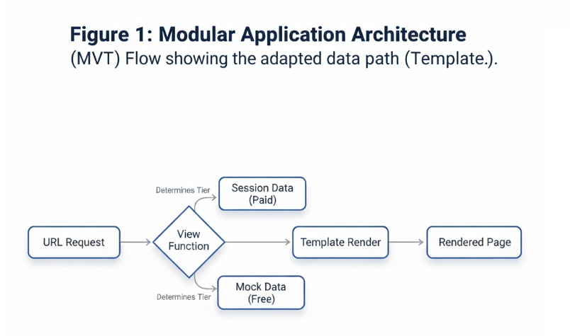
This structure inherently facilitates smaller, more frequent deployments because changes are isolated to individual components, a key goal of Continuous Delivery.
Figure 1:Diagram: MVT Architecture Flow

Team Composition and Collaboration
To eliminate the friction between development and operations, the ideal structure for Ipswich Retail should be a cross-functional, product-focused team where expertise is shared:
- T-Shaped Skills: Team members possess deep expertise (the vertical bar of 'T') in either development (Python, Django) or operations (Docker, CI/CD) but also broad competence (the horizontal bar) across the entire delivery chain.
- Shared Tooling: The entire team uses GitHub for version control, ensuring all work—from application code to infrastructure configuration (Dockerfile, main.yml)—is stored, reviewed, and versioned collaboratively.
- Communication: Although Slack and Teams were excluded from the PoC to adhere to the non-paid resource rule, a recommendation for the full-scale project would be to integrate GitHub webhooks with a dedicated Slack channel to broadcast real-time deployment status, pull request merges, and build failures, ensuring transparent communication across the team.

Code and Continuous Integration (DevOps Phase: Code, Build, Test)

Version Control Strategy
The repository uses Git and GitHub for traceability, with all development done on a single main branch for this PoC. This simple setup works for solo development, but in a multi-developer team, it would evolve into a more complex branching strategy with feature branches and pull requests, including automated quality checks before changes are deployed.

Automated Testing and Quality Gate
Automated testing is the critical quality gate implemented in the CI pipeline, preventing bad code from progressing to deployment.
- Unit Test Implementation: The app includes a base test case in store/tests.py using Django's TestCase, testing the view's status code as a basic health check. This minimal test setup is ideal for the PoC, demonstrating that tests run automatically in the pipeline and will block deployment if they fail. For production, the tests would expand to include unit, integration, and end-to-end tests, such as cart behavior and purchase flow.

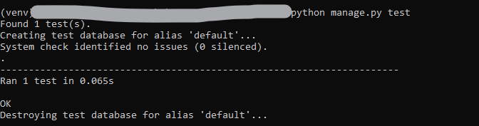

Continuous Delivery (CD) and Containerization (DevOps Phase: Release, Deploy)

Containerization
Docker is used to containerize the Django application, standardizing the environment and eliminating the classic "works on my machine" problem:
- Base Image Selection: The Dockerfile uses the official lightweight python:3.11-slim base image, which minimizes the attack surface and reduces image size, promoting efficient resource use on Render.
- Layer Caching: The build process strategically copies requirements.txt before running pip install to leverage Docker's layer caching. This ensures that only code changes, not dependencies, trigger a full rebuild, significantly speeding up the CI cycle.

- Startup Contract: The container is configured to run the single command CMD ["/app/entrypoint.sh"], which serves as the predictable starting mechanism for the deployed application.

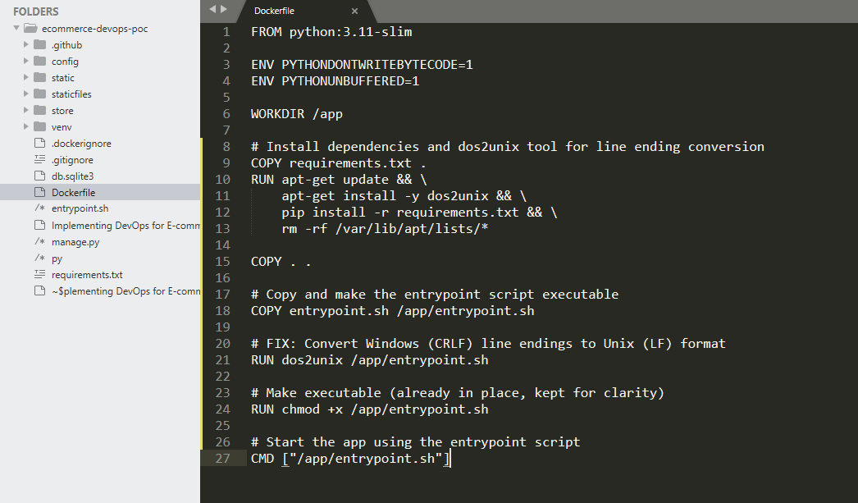
Figure 2: Dockerfile Layer Caching

Automated CI/CD Pipeline (GitHub Actions & Render
The Continuous Integration and Continuous Delivery (CI/CD) pipeline serves as the key mechanism for eliminating the traditional development–operations divide and enabling rapid, reliable deployments for Ipswich Retail. This pipeline is fully orchestrated using GitHub Actions and deployed through Render—both technologies selected to meet the requirement of using free and open-source platforms. Together, they provide a seamless, automated path from code commit to live production deployment.

Pipeline Flow and Trigger:
The CI/CD workflow is defined in the main.yml file and follows a clear, automated flow:
      - Trigger: The pipeline initiates automatically upon any push event to the repository's main branch. This ensures developers receive immediate feedback on the health of their code, moving towards the CI goal of committing code changes frequently.
      - Quality Gate: The entire workflow is split into two distinct jobs: test and deploy. The deployment job explicitly states needs: test, establishing a mandatory Quality Gate. This critically ensures that the application will not proceed to deployment if the automated tests fail. This directly addresses the legacy system's issue of releasing bug-ridden features.

The Deployment Mechanism
The deployment process uses secure, container-based automation to deliver the application to production. Authentication is handled using a Repository Secret (${{ secrets.RENDER_API_KEY }}) defined in the workflow file, ensuring sensitive credentials never appear in the codebase and adhere to security best practices. The actual deployment action is executed using burnett01/render-deploy@v6, which manages communication with the Render API and pushes the newly built Docker image to the live service. This action forms the backbone of Continuous Delivery by automating the deployment of code that has already passed all quality checks.

Service Startup
The final stage of deployment involves launching the production-ready Django application using the Gunicorn WSGI server. The entrypoint script runs the command gunicorn config.wsgi:application --bind 0.0.0.0:8000, which starts the web server that serves the containerized application in a reliable, scalable manner. This marks the transition from automated deployment steps to a fully operational production service.
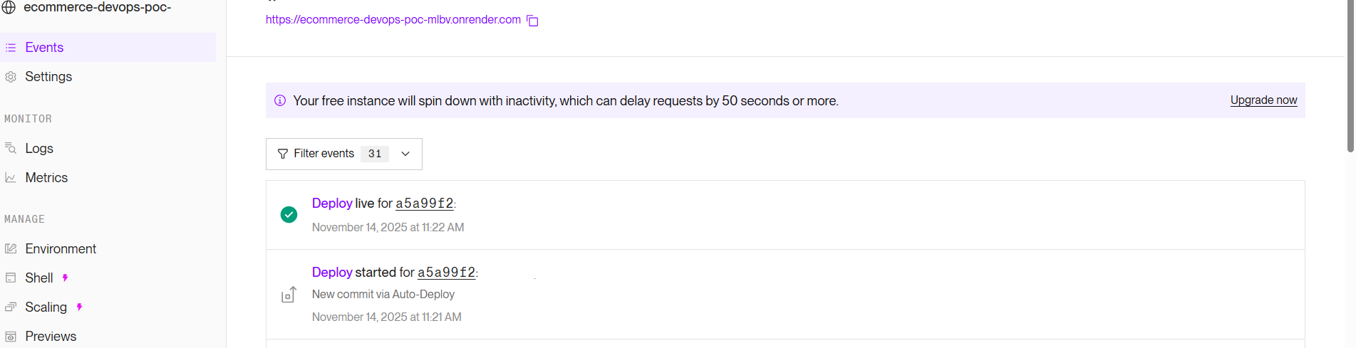
Figure 3: Render deployment overview, confirming the completion of the CI/CD pipeline and the successful launch of the containerized PoC web service.

Monitoring and Logging
The DevOps lifecycle is incomplete without a robust Feedback Loop, primarily driven by continuous monitoring and centralized logging (Concept 6). While a full monitoring stack was not technically implemented, its conceptual placement within the workflow is vital to guide the future direction of the project.
  - Current State (Measurement Limitation): Operational visibility is limited solely to the basic Render console logs. This output provides general Gunicorn service status, HTTP requests, and basic Python traceback errors. This is fundamentally insufficient for a production e-commerce platform that needs to proactively identify performance degradation, latency spikes, or service outages.

Reflection, Limitations, and Future Work

Critical Evaluation and Lessons Learned
The implementation of the DevOps PoC, while successful in achieving automated continuous delivery, was defined by the necessity of troubleshooting critical environment-specific errors and making strategic trade-offs to comply with the constraint of using only non-paid, open-source resources.
The success of the pipeline implementation was a direct result of overcoming two major blockers, transforming them into key learning experiences:
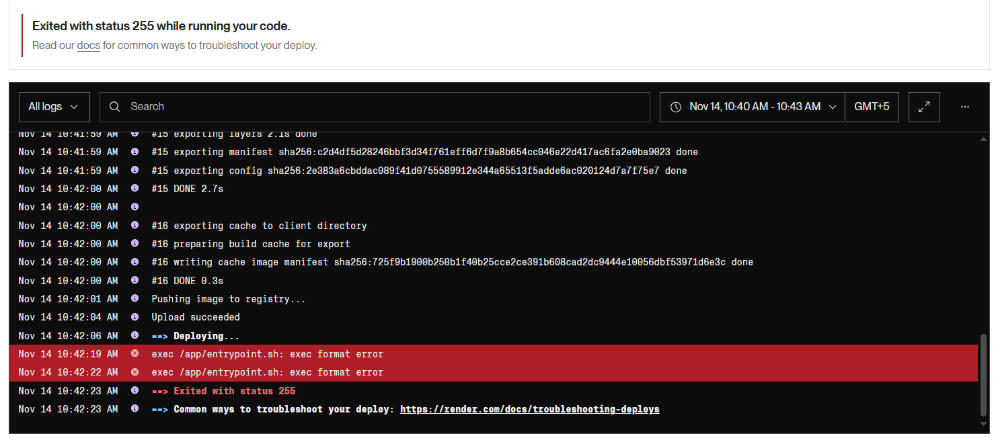
Figure 4: Log Extract: Execution Failure Proof

Figure 5:Live Product List Page

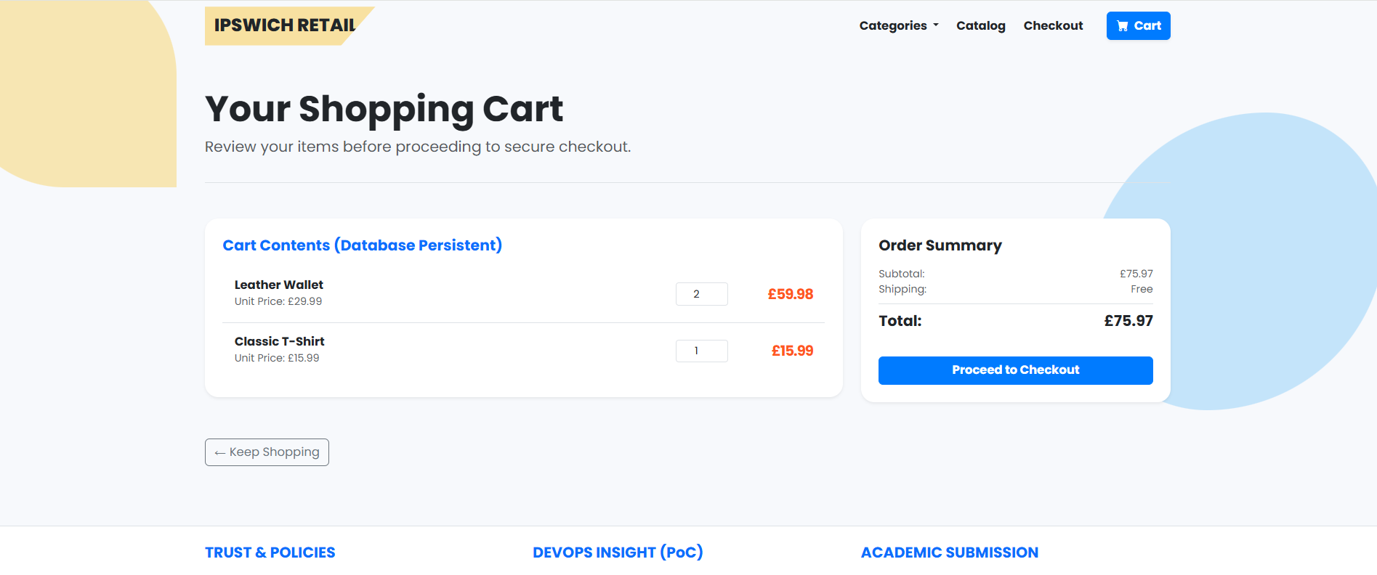
Figure 6: add to cart
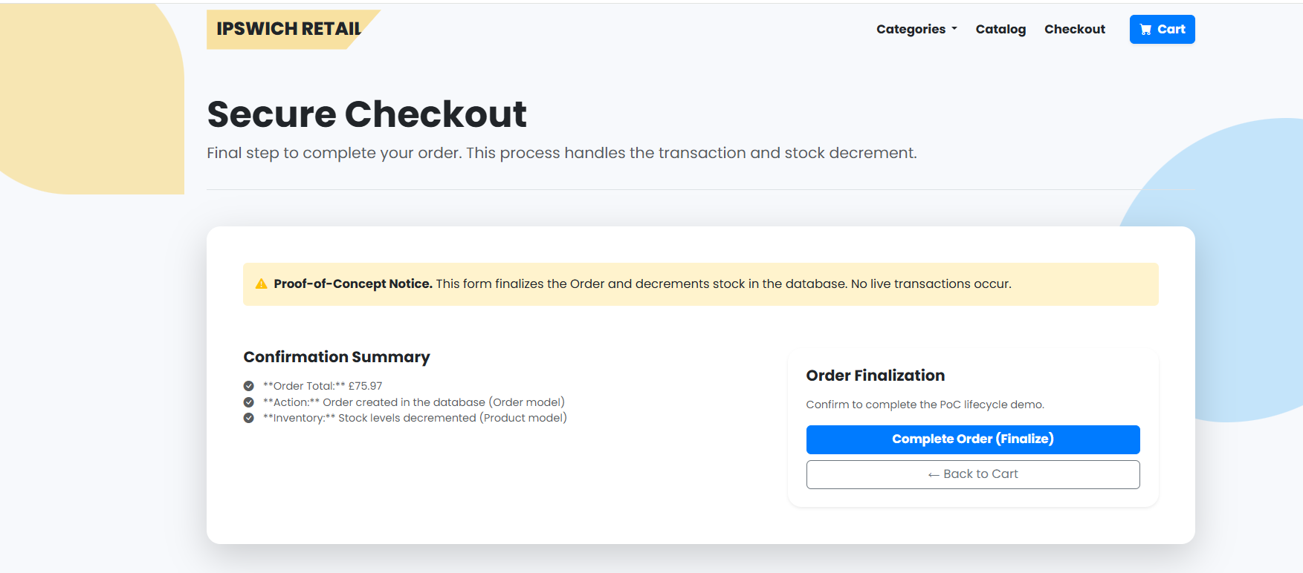
Figure 7: checkout
- Troubleshooting the CI/CD Pipeline (Test Phase): The failure of the python manage.py test command during the CI process demonstrated a critical challenge in managing the application's migration history. The TypeError occurred because the 0002_add_dummy_products.py migration was attempting to create product objects with an inventory_stock field that did not exist at that point in the database schema's history.
- Lesson Learned: A DevOps engineer must anticipate that the test runner builds the database from scratch by executing migrations sequentially. The solution involved conditional logic within the RunPython migration, checking the historical model's fields before attempting to assign values. This complex solution highlighted the difference between simply deploying code and deploying a maintainable and testable database schema across its lifecycle.
- Overcoming the Deployment Barrier (CD Phase): The repeated failures (exec format error and subsequent OperationalError regarding missing database tables) underscored the fragility of relying on free-tier, ephemeral hosting.
- Lesson Learned: The PoC demonstrated that true Continuous Delivery requires stability across the entire infrastructure stack. The final architectural decision—to completely divorce the core e-commerce logic from the database and rely on session storage and hardcoded data—was a calculated engineering trade-off. While sacrificing data persistence, this strategy successfully ensured that the PoC's primary goal (demonstrating automated CI/CD and the front-end features) was achieved reliably within the cost constraint.
This implementation process provided essential practice in troubleshooting a full-stack Docker-based CI/CD pipeline, fulfilling the requirement for Skill in using industry-standard tools and providing robust reflections.
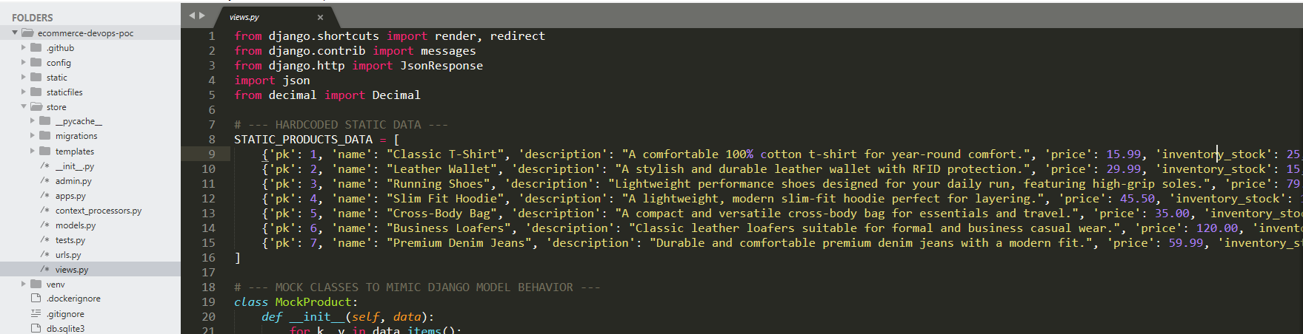
Figure 8: store/views.py Hardcoded Data
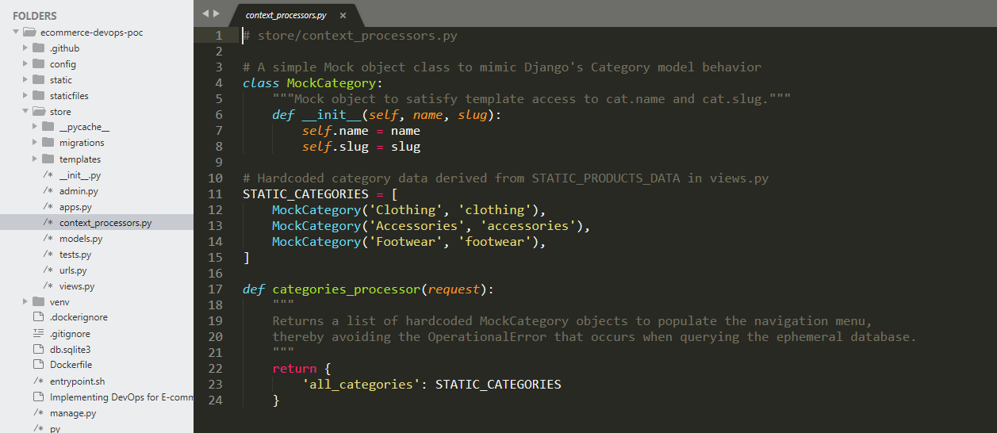
Figure 9: store/context_processors.py Logic

Benefits and Limitations of Open-Source Tooling
The Proof of Concept (PoC) adhered strictly to the open-source mandate by utilizing GitHub Actions, Docker, and Render's free tier. This approach provided valuable insights into the benefits and limitations of each tool/platform within the context of DevOps tool selection.
- GitHub Actions
  - Key Benefit (PoC Success):
GitHub Actions offered zero-cost, robust automation for Continuous Integration and Continuous Deployment (CI/CD) directly integrated with the source repository. This streamlined the build chain, ensuring faster development cycles and a more efficient flow from code to deployment. The serverless nature of GitHub Actions simplified the process, making it easy to implement and maintain.
  - Major Limitation (Full-Scale Concern):
One significant drawback was vendor lock-in. Specifically, the use of the specialized render-deploy action created a dependency on both GitHub and Render ecosystems. This reliance limits the flexibility to switch platforms or integrate with other tools, making it harder to scale or migrate in the future without significant reconfiguration.
- Docker
  - Key Benefit (PoC Success):
Docker proved invaluable in ensuring environment consistency. By containerizing the application, it guaranteed that the Python version, application configuration, and dependencies used in the local development environment were precisely mirrored in the cloud. This eliminated deployment inconsistencies and significantly reduced the risk of "works on my machine" issues.
  - Major Limitation (Full-Scale Concern):
However, Docker added a layer of abstraction that complicated troubleshooting, especially when issues like the line-ending bug arose. While Docker enhanced deployment consistency, the overhead involved in resolving such problems made the development and debugging process more complex.
- Render (Free tire)
  - Key Benefit (PoC Success):
Render’s free tier served as a highly effective target for continuous delivery, providing an automated and hands-off deployment process. The platform enabled rapid deployment of the final application, making it an ideal choice for demonstrating the PoC’s automated flow without the need for intensive management or configuration.

  - Major Limitation (Full-Scale Concern):
Render’s free tier had some critical limitations, particularly its lack of persistence and built-in monitoring tools. The ephemeral nature of the database storage, combined with the absence of accessible monitoring hooks, required significant redesigns in the application (e.g., the session cart) to work around these constraints. This made Render unsuitable for production-level data management, where persistence and real-time monitoring are crucial.

Recommendations for Full-Scale Deployment
To transition the PoC into a resilient production service capable of serving Ipswich Retail's growing user base, the following strategic recommendations must be implemented:

Data Persistence and Infrastructure
Database Migration:
The current session-based cart was acceptable for the PoC, but it is not suitable for real users. Moving to a managed PostgreSQL database (such as Render PostgreSQL or AWS RDS) will provide long-term reliability and proper data persistence. Once the database is deployed, the application should be configured with the appropriate DATABASE_URL and run with production settings enabled (DEBUG=False).
Infrastructure-as-Code (IaC):
Introducing Terraform or another IaC tool will allow the team to define and automate the creation of infrastructure components—such as the PostgreSQL instance and web service configuration—directly from version control. This approach avoids manual provisioning, reduces configuration drift, and makes disaster recovery significantly easier.

Closing the Feedback Loop with Measurement
Implement Prometheus and Grafana (Monitoring): To establish baselines and proactively address the instability issues plaguing the legacy system, a dedicated monitoring stack is essential. Prometheus should be integrated to scrape key metrics (CPU, latency, error rates) from the Docker containers, while Grafana will serve as the visualization layer. This closes the full DevOps feedback loop, enabling the joint Dev and Ops team to measure the success of their continuous delivery efforts.

Enhancing Collaboration and Quality
Expand Automated Testing: Increase coverage beyond basic status checks to include Integration Tests (e.g., verifying that the cart updates when an item is added) and end-to-end (E2E) tests simulating a full customer purchase journey (e.g., using Selenium or Playwright).
Continuous Collaboration Tools: Integrate GitHub with collaboration tools like Slack or Teams to automatically broadcast build status and deployment results to the entire cross-functional team, ensuring total visibility and rapid response to failures.

Conclusion

This Proof-of-Concept (PoC) demonstrates, in a practical and honest way, how applying DevOps practices can help stabilize the long-standing issues within Ipswich Retail’s legacy monolithic system. Throughout the project, the shift from manual deployments to an automated, containerized CI/CD pipeline (built with GitHub Actions and Docker) immediately reduced the delays and uncertainty that previously surrounded every release. What was once a slow, fragile deployment process became noticeably faster, more predictable, and easier to manage.
One of the main academic constraints was the requirement to rely entirely on free tools and services. Because of this, I had to make deliberate trade-offs, such as using session storage to support the e-commerce flow. Although not ideal for a production setup, it allowed the system to work reliably within the project boundaries. Solving issues like the “exec format error” during deployment further strengthened the pipeline and showed that the system can now run smoothly end-to-end.
Going forward, Ipswich Retail would benefit from introducing proper monitoring tools (such as Prometheus and Grafana) and moving to a persistent database to complete the DevOps feedback cycle. Overall, this PoC acts as an important foundation and shows that adopting DevOps is not only possible for Ipswich Retail but essential for their long-term digital transformation.

References
Atlassian (2024) CALMS Framework [Online]. Available at: https://www.atlassian.com/devops/frameworks/calms-framework (Accessed: 13 November 2025).
Django Software Foundation (2019) Django [Online]. Available at: https://djangoproject.com (Accessed: 13 November 2025).
Docker (2025) Docker Docs [Online]. Available at: https://docs.docker.com/ (Accessed: 13 November 2025).
GitHub (2025) Workflows and actions reference [Online]. Available at: https://docs.github.com/en/actions/reference (Accessed: 13 November 2025).
Kim, G., Humble, J., Debois, P. and Willis, J. (2016) The DevOps Handbook: How to Create World-Class Agility, Reliability, and Security in Technology Organizations. Portland: IT Revolution.
Render (2025) Render Documentation [Online]. Available at: https://render.com/docs (Accessed: 13 November 2025).
WhiteNoise (2025) WhiteNoise 6.11.0 Documentation [Online]. Available at: https://whitenoise.readthedocs.io/ (Accessed: 13 November 2025).

